**Background/Theme/General Design:**

* Different background themes?
* Our colors are green, black and white
* We would like it to look more professional. Yes it is for information for the junior fair, the kids, but mainly the parents would use the website.
  + Remove cartoon animals (We would get a lot of grief for animals that don’t look right haha) Maybe use silhouettes of real show animals.
  + Remove color blobs in the background.
  + This is an example of a lot of our signs and displays:

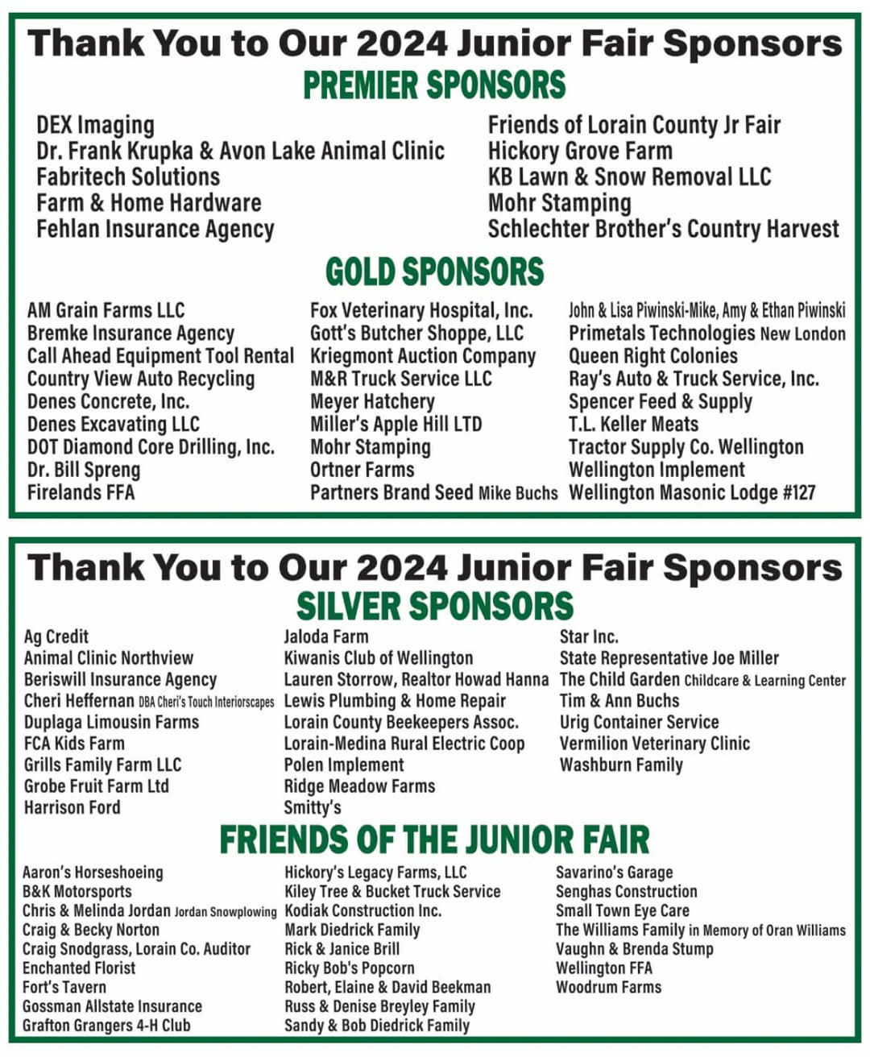

* The very top & very bottom colors and layout are perfect design wise! Like the black & white.
* Next the logos on top of pages & bottom remove the “lcjfb”
* Change logo’s to Black
* “Junior Fair Apparel Sale” tab make it just say “Apparel Sale”
* “Join Us/Book Now” button on the top of each page could we make this like a shopping cart?
  + We click the button and it would take us to our Zefty account where they have the option to see all our items for sale/sponsor. (Apparel, stock the trailer donors, jfb sponsors, & award sponsors)
  + Jennifer is working on getting all the zeffy links together.
* Remove phone number & hours section at the bottom (We don’t have those)
  + Add: JFB drop box at barn #14 on the fairgrounds
* Social media icons on the bottom - remove twitter & instagram - add you tube icon
* We like the red oval link icons at the top of each page.
  + Trying to make it straight forward without parents having to dig for information.
  + Can we make them green?
  + We would like to have a link button for each section on the top of each page. Once we click it, it will scroll right to that place on the page.

**Homepage:**

* Welcome Section:
  + “Welcome to LC Fair” make it “Lorain County Junior Fair Board” (Spelled out & remove “welcome to” because it’s in the next section)
  + Move Join us button under board picture.
    - Then change/add the buttons:
      * Fair Week Schedule
      * Junior Fair Map
      * Facebook Link
      * YouTube Link
* Calendar section:
  + If they click “Download” could we make this our Google Calendar?
    - Also Download spelling (Doanload)
  + Is the image that appears, an image of the current month activities or do we need to update it every month? Could we add our google calendar directly to the website?
* Fair theme section:
  + Right before the fair book section we would like to add a section for our current fair theme name and design.
  + “2025 Fair Theme: Go Hog Wild”
* Fair Book Section:
  + Perfect!
* Fair Week Schedule section:
  + Download Spelling (Doanload)
* Our core values section:
  + Remove we don’t really have
* Junior Fair Map:
  + Perfect
* Meet your Board Officers:
  + Remove this from the homepage. Just limited double information to make things easier, so people don’t have to waid through extra information.
* Facebook Section:
  + Perfect!
  + Do the images automatically change as we add things to facebook or do we just need to update?
* You Tube Section:
  + Add something similar as the Facebook section for our You Tube Channel.
  + Will the preview images change or do we need to update occasionally?
* What is the Join our community Link?

**History**

* Top Section:
  + Meet your board offices section move below links.
  + How JGB Runs to “How JFB Runs”
  + Officers link make it say Current Officers
  + Where the “Know more” link is:
    - Add/Change link buttons:
      * Past Board Pictures
      * Our Timeline
      * Past Kings & Queens
      * Past Officers
* Add Current Officers section right above Past Board Pictures
  + Move the Meet your Board Officers message at the top to this section
  + Will have pictures and info of current officers in this section. 8 kids each year.
* The Rest looks great!

**Fair Entry**

* Looks Great!
* Reorder - move the Register now section to the top

**Forms**

* How does this work?
  + When we click the “forms” tab would a page open listing all our forms? Then we can click the form we need, would it open a new page or scroll to that section the form is in?
  + Tabs:
    - Junior Fair BBR (Born, Bred, and Raised) Form
    - Junior Fair Board Member & Assistant Application
    - Junior Fair Health Form
    - Junior Fair Board Adult Consultant Form
    - Junior Fair T-shirt Design Form
    - Junior Fair Thank you Card Design Form
    - Junior Fair Activity Form
    - Lorain County Junior Fair Scholarship Application
    - Junior Fair King & Queen Application
    - Stock the Trailer 4-H/FFA Contest Form
* Junior Fair BBR Form Section:
  + All 3 form buttons same color
  + “BeefN Form” to “Beef Form”
  + When we scroll down to each section (beef, goat, sheep), what are the Form images? Is this the actual form they can fill out online? If so, where would this information go? Could we make forms on the website to gather information for misc projects/requirements?

**Sponsorship**

* Top of page
  + Remove link to goat form
  + Make all links on top of the page the same color.
  + Tabs:
    - 2024 Sponsorships
    - Sponsorship levels
    - Sponsorship application
    - Why Sponsor?
* Sponsorship Section:
  + Rename to “2024 Sponsorships”
  + Remove Hearts.
  + Break it up in by sponsor levels
  + Can just upload images use above for example.
* Slideshow section:
  + Remove “sponsorship 2024 slideshow” header & description
    - Combining with the “2024 Sponsorship” section. Just have the logo slideshow.
  + We have a powerpoint already made for sponsorship logos, could we just upload this to this section? Could it just automatically run as well? Or do we have to upload each logo?
* *Move the sponsorship level section to be right after the slideshow section*
* Sponsorship levels section:
  + Remove the vip images
  + Just list the levels in order.
* Sponsorship form section:
  + Rename:
    - Junior Fair Sponsorship Application
  + Remove the form image.
  + Instead of a download button make this the link to zefty for sponsorships.
* Why Sponsor section:
  + Change Gain exposure from “50,000+” to “100,000+”
  + Remove “Join us” button
* Be one of our sponsors
  + Remove this section

**Stock the Trailer**

* Top section:
  + Remove the "farm credit mid of america” link
  + List tabs for each section on this page like the current “Farm Credit” tab to click and scroll to that section - remove green & purple link blocks.
    - Tabs:
      * Previous Year Placings
      * Club Competition
      * Past Club Winners
      * Donate Here
      * Our Food Banks
      * News Media
* Club competition section:
  + Is the "join now” button the link for the form?
* Our donor section:
  + Add link to zeffy for donors to donate monetary donations towards purchasing food.
* Add section after donors section
  + “Where does the food go”
  + We will list all our food banks here

**Livestock Auction:**

* Tabs:
  + Sale Day Schedule
  + Livestock Add-on Bids
  + Livestock Sale Facebook
  + Dairy Auction Facebook
  + Buyer Picture Examples
  + Letter Examples
* Add “Livestock Add-on Bid” section right under schedule section
  + We will have a link for people who are unable to make the auction or can’t buy their animal to give something extra to these kids.
  + This link is not through zefy it will be something given to us by livestock sale.
* Add “Dairy Auction Facebook” section right under Livestock Sale Auction Facebook
  + Similar to what we have for Livestock sales.
* Add “Buyer Picture Example” section right above “ Letter Examples”
  + Similar to what we have for Letter Examples

**Apparel Sale:**

* Sale day schedule - make link to zefy - “Purchase Apparel Here”
* Everything else looks great!

**Departments:**

We changed our mind on how we want these department pages to look. We are trying to make it easier on us year to year to make sure all information is always up to date and nothing is out of date. By doing that we are going to remove information they could find easily in our book. Less for us to keep up to date.

* How does this page work?
  + When we click the “department” tab would a page open listing all our departments? Then we can click the department we need, then would it open a new page design just for that department?
  + Tabs:
    - Beef
    - Dairy
    - Dog
    - Goat
    - Fowl
    - Sheep
    - Horse
    - Swine
    - Small Animal
    - Special Events
    - Ag & Home Ec.
* Department Pages:

All department pages will look similar to this listed below:

* + Join us link
    - Add/Change to:
      * Rules/Requirements
      * Junior Fair Book
      * YouTube Video
  + Schedule Link Change to
    - Pre Fair Schedule
      * Here will will have schedules & other deadline dates listed
  + Department officers section
    - Remove this section
  + Add section “Download Our Junior Fair Book” right above “Pre Fair Requirements” section
    - All fair week schedules, rules, and department information to be found in the Junior Fair Book.
    - When we link the book, could we link it so it opens right to the departments page?
    - If we can’t have it open right to the page. We will list three things:
      * Schedule Page
      * General Rules Page
      * Department Page
  + Add section:
    - A place to link our YouTube page.
      * Every year our departments each make their own video specific to their department of all the changes, rules, barn layouts, etc.
  + Department Year Schedule section:
    - Change title to “Pre Fair Requirements”
    - We will only list pre fair schedules & other deadline dates here.
    - Removing - Fair Check In, fair weigh in, fair show schedule, auction, fair release schedule. (All things found in our fair book easily and less to update year to year)
  + Fair Map section:
    - This will just be an image we will upload of where the beef barn is, where to unload & how to enter the fairgrounds. Kinda similar to the one on the homepage.
  + Remove “Join our community today?